Event numbers 2019023112 and 2019023113 (obedience)
Port Chester OTC
220 Ferris Avenue
White Plains, NY 10603

15 Goat Hill Rd.
Saugerties, NY 12477
Beginner Novice A and B
Novice A and B
Open A and B
Utility A and B
Obedience Trials limited to 7 hours of judging per trial
Entries close at 5:00 PM, Wednesday October 16, 2019 or when the numerical limits have been reached, after which time entries cannot be accepted, canceled or substituted, except as provided for in Chapter 11, Section 6 of the Dog Show rules

Premium List
118th and 119th Obedience Trials
(unbenched)

PORT CHESTER OBEDIENCE
TRAINING CLUB, INC

(Member of the American Kennel Club)

PCOTC Training Facility - 220 Ferris Avenue, White Plains, NY 10603

Sunday November 3, 2019

Trial hours 9:00 a.m. – 5:00 p.m., Facility opens at 8:00 a.m.

ENTRIES HEARTILY ACCEPTED FOR DOGS LISTED IN
THE AKC CANINE PARTNERS PROGRAM

Go green and get it faster!
Email address on entry form will get you your confirmation faster!
2016 Officers of the Port Chester Obedience Training Club, Inc.

President Barbara Napoli
1st Vice President Sara Gagnon
2nd Vice President Margaret DeFonce
Treasurer Mary Skirchak
Recording Secretary Donna Fanok
Corresponding Secretary Olga Kornienko
440 N Broadway, Apt. 21, Yonkers, NY 10701, Olga.pcotc@gmail.com
Board of Directors
Morgaana Menzel Deedie Domenicalli

AKC Delegate
Kathy Gregory

Trial Committee
Bruce Sheffler, Obedience Chair
14 Applebee Farm Lane, Croton on Hudson, NY 10520
brilligs2@optonline.net
Lori Carver, Event Secretary
P.O. Box 1204, 91 Michael Sears Rd, Belchertown, MA 01007
802 338-2857 seabreezedogs13@gmail.com
Chief Steward: Morgaana Menzel
Hospitality:Joanne Sheffler
Grounds Bruce Sheffler

Stewards PCOTC members

Veterinarian on call 24 hours
Veterinary Emergency Group
193 Tarrytown Rd. White Plains, NY 914-949-8779
“Exhibitors should follow their veterinarians’ recommendation to assure their dogs are free of internal and external parasites, any communicable diseases, and have appropriate vaccines”

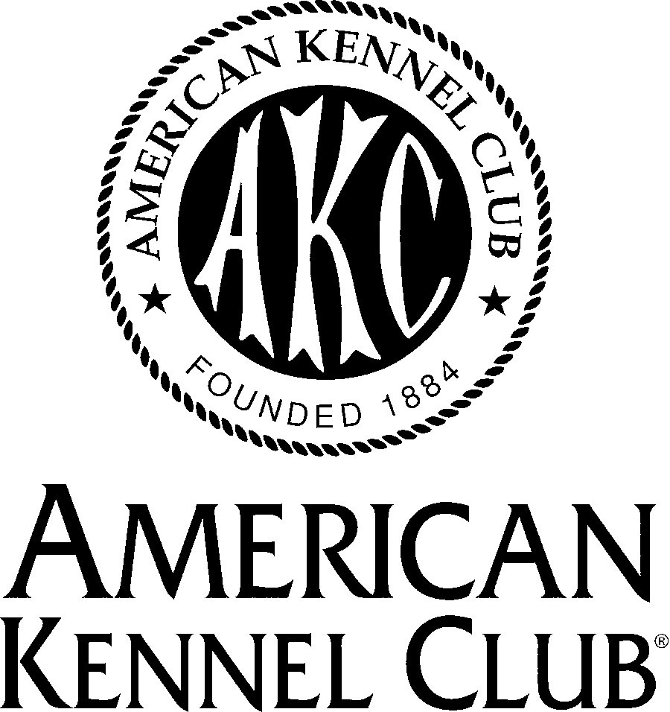
Certification
Permission is granted by the American Kennel Club for the holding of these trials under American Kennel Club rules and Regulations.

Gina M. DiNardo, Secretary

Important exhibitor notices

Site notices
There are 2’ x 2’ pillars in our rings.
Although very close, this diagram is not 100% to
scale.

This is a dog training facility.
Being a popular and well-used training facility means it is subject to the smells and visual distractions inherent in such a facility. To the best of our ability, the ring areas are thoroughly cleaned and odors neutralized but there will likely be stains on the mats.

Due to space constraints, No X-pens

Dogs must be on leash at all times in and outside the facility unless being shown.

Please do not let dogs relieve themselves on the church property across the street.

Should you forget your own; water, crates, chairs, and waste removal products are available for your use.

Parking
Parking is available in our lot behind the facility. You may park in areas marked “loading zone” in our parking lot. When the lot fills, please park on surrounding streets.

Sunday the 2 hour limit is NOT enforced but there is a church across the street whose members also park on the street mid/late morning. Arrive early for the closest-to-the-facility street parking.

Hospitality
Coffee and pastries will be available in the morning. You are welcome to use our refrigerator, freezer and microwave. Driving directions to the nearest pizza place, grocery store and Subway will be available at the show.

Email Addresses
For fastest delivery of your confirmation provide an email address on your entry form!! When confirmations go out after the closing date; your confirmation can come by email that same day or you can wait 2-3 days for the post office to deliver it.

Entry Form Legibility
Please ~ carefully PRINT LEGIBLY on your entry form. If the secretary cannot read your entry, it is not valid/accepted until the secretary gets the information and you may get shut out!
Please send ONE check PER DOG, PER TRIAL.
Scheduling information

These trials will run CONCURRENTLY and will start at 9:00am.

Concurrent trials allow us to, ideally, schedule your 2 runs, in 4 hours or less! Two runs with a fresh dog instead of a sleepy, stiff, tired dog that’s spent hours in a crate waiting for a PM trial to start.

Additionally, it allows us to accommodate more exhibitors in our parking lot. By getting exhibitors in/out in the morning, parking for other exhibitors opens up in the afternoon.

It does not matter if your run in trial 2 happens before your run in Trial 1.

There can be no day-of transfers (move ups) once the trials start. If you Q in one trial, a transfer (move up) is not possible for the other trial. This is because the transfer form must be received before the trial starts. Since they both start at the same time you cannot Q in one trial then move up at the next.

Obedience trial schedule

Multiple dogs + multiple classes + one handler = conflicts. Conflicts will be handled the day of the show.

To help you visualize it, below is one possible schedule

Ring 2 / Trial 2
Utility A/B
Open A/B
Beginner Novice A/B
Novice A/B

Ring 1 / Trial 1
Novice A/B
Beginner Novice A/B
Open A/B
Utility A/B

Preferred Open

AKC Code of Sportsmanship

PREFACE: The sport of purebred dog competitive events dates prior to 1884, the year of AKC’s birth. Shared values of those involved in the sport include principles of sportsmanship. They are practiced in all sectors of our sport: conformation, performance and companion. Many believe that these principles of sportsmanship are the prime reason why our sport has thrived for over one hundred years. With the belief that it is useful to periodically articulate the fundamentals of our sport, this code is presented.

• Sportsmen respect the history, traditions and integrity of the sport of purebred dogs. • Sportsmen commit themselves to values of fair play, honesty, courtesy, and vigorous competition, as well as winning and losing with grace. • Sportsmen refuse to compromise their commitment and obligation to the sport of purebred dogs by injecting personal advantage or consideration into their decisions or behavior. • The sportsman judge judges only on the merits of the dogs and considers no other factors. • The sportsman judge or exhibitor accepts constructive criticism. • The sportsman exhibitor declines to enter or exhibit under a judge where it might reasonably appear that the judge’s placements could be based on something other than the merits of the dogs. • The sportsman exhibitor refuses to compromise the impartiality of a judge. • The sportsman respects the AKC bylaws, rules, regulations and policies governing the sport of purebred dogs. • Sportsmen find that vigorous competition and civility are not inconsistent and are able to appreciate the merit of their competition and the effort of competitors. • Sportsmen welcome, encourage and support newcomers to the sport. • Sportsmen will deal fairly with all those who trade with them. • Sportsmen are willing to share honest and open appraisals of both the strengths and weaknesses of their breeding stock. • Sportsmen spurn any opportunity to take personal advantage of positions offered or bestowed upon them. • Sportsmen always consider as paramount the welfare of their dog. • Sportsmen refuse to embarrass the sport, the American Kennel Club, or themselves while taking part in the sport.
Notice to exhibitors
Telegraph, Telephone, Fax, Email and unsigned entries cannot be accepted. Entries not on official AKC entry forms, downloaded and/or photocopies of entry forms without agreement and rules on the reverse side of the official AKC entry form are not acceptable.
Mail all entries with fees to Lori Carver, 91 Michael Sears Rd, Belchertown, MA 01007. Entries received without fees will not be accepted. Confirmation via email will be made no later than 7 days before the trial. Exhibitors who do not provide an email address will receive entry confirmation via USPS. Should confirmation (email or USPS) not be received by the exhibitor within 7 days of the trial please contact the trial secretary.
Make all checks and money orders payable to PCOTC, no credit or debit cards will be accepted for payment. Canadian exhibitors must make fees payable in U.S. funds. The trial Secretary assumes no responsibility for cash sent through the mail. Tabulate carefully. Due to the cost of processing no refunds of $4.00 and under will be made.
An AKC recording free of .50 first entry only and an AKC Event service fee of $3.50 per entry will be required for each dog entered ay any licensed or member club show, obedience trials or tracking test. An AKC recording fee of $.50 will be required for each entry in any licensed or member club rally trial. All recording and event service fees are paid to the AKC.
No entry shall be made and no entry shall be accepted which specifies any conditions as to its acceptance—multiple entries made by one handler will be spaced day of the show. Be prepared to have an extra handler for obedience stays if showing more than one dog!
Entry fees shall not be refunded in the event that a dog is absent, disqualified, excused by veterinarian or judge or barred from competition by action of the event committee. If because of riots, wars, strikes, civil disturbances, national emergencies, health emergencies, and dictates of law enforcement or the owners(s) of the grounds and/or facilities or other acts beyond the control of the management it is impossible to open or to complete the event, no refund of entry fee will be made. Extreme weather conditions, such as, but not limited to snow storms, hurricanes, lightning, extreme heat, heavy rains, or other circumstances including but not limited to the condition of the facilities or grounds and /or the ingress and egress from the grounds, must be considered to the health and safety of the dogs, exhibitors and spectators. The well-being of dogs, exhibitors and spectators is of paramount importance and in the event it is necessary to cancel or stop the event before completion, no refund of entry will be made. To find out about any AKC event cancellation call the AKC Event Cancellation Hotline 877-252-3229.
Postdated checks, returned checks do not constitute valid entry. If limits are met and your check is returned, the entry will be denied and that spot given to someone on the waitlist. If the trial is not full, the trial secretary will add a collection fee to the amount of each returned check of $40 and entry must then be made with money order only and paid prior to the closing date.
An administrative fee of $5.00 will be withheld from refunds for processed duplicate entries discovered after the closing date. Every effort will be made to find and return duplicate entries before processing.
Errors on entry forms: Owners are responsible for errors in making out entry forms, regardless of whomever may make such errors, and no entry fee will be refunded in event of such errors or cancellation of entries after the closing date.
Each Owner and agent listed on the entry form and/or individual responsible for the dog at a show is bound by the certification and agreement on the front and back of the entry form regardless of who may have completed and submitted the entry form.
As specified in Chapter 12, section 4, of the AKC rules applying to dog shows, information contained on the entry form is required to be published in the show’s catalog. This information is also subject to publication in other media.
Dogs may arrive any time prior to their scheduled time for judging—the facility will open at 8:00am. Dogs not required for further judging will be excused.
Judges will not wait for any dog holding up a class. Owners or agents alone are responsible for the presence of their dogs in the judging ring when their classes are called to be judged.
All dogs present must be held on leash or confined to their crates except when being judged.
All dog feces must be picked up, failure to do so will result in a trial committee hearing and excusal from the show grounds without refund of entry fees.
No gasoline or diesel generators. No electrical hook up inside the facility.
AKC Rules, Regulations, Policies and Guidelines are available on the American Kennel Club Web site, www.akc.org

Obedience Trial Judges
Mr. Michael Mooney……………26 Shetland Cir. Reisterstown, MD, 2436
Trial #1

Ms. Teresa Walker ……………..499 Sergeantsville Rd, Femington, NJ 08822
Trial #2

Ribbon Prizes

Obedience
First Prize Blue Rosette
Second Prize Red Rosette
Third Prize Yellow Rosette
Fourth Prize White Rosette

Rosettes will be presented for new titles, highest scoring dog in open B and utility B combined, and highest scoring dog in regular classes,
A dark green qualifying score ribbon will be given to each dog receiving a qualifying score.

Obedience Classes
Qualifying score required for all prizes in regular classes
“Dog” means either sex. Transfers (formerly known as move ups) will be allowed after the closing date and up to one-half hour before both trials begin (8:30 a.m.). There cannot be any transfers after 8:30 a.m.as both trials start at 9:00. Refund of entry fee less $5.00 will be given to bitches in season with a written notice from the veterinarian. The note must be presented to the trial secretary before the start of judging.

CLASSES OFFERED
Beginner Novice A and B
Novice A and B;
Open A and B;
Utility A and B

All classes will run in catalog order.

Conflicts will be handled the day of the show and exhibitors will get their runs with ample warm up—don’t stress out.

Any ribbon not claimed by the end of this trial will become the property of the Port Chester OTC, Inc. None will be mailed

Notice
All rights to TELEVISE, VIDEOTAPE, ADVERTISE, PHOTOGRAPH, PROMOTE or otherwise exploit these events are vested in the club, or in persons to whom assignments of such rights have been made in writing by the club. All persons and animals on the show grounds at any time while this event is in progress, do by attending this event or participating therein, grant to the club the right to photograph, televise, videotape, audiotape or otherwise use their likeness and voice in any manner without further release or consent. This event may be televised. Video and photographs taken at this event may be used in upcoming PCOTC videos or posted on our YouTube and Facebook pages.

Accomodations
Be sure to check pet policy before booking
Hotels that allow dogs are getting harder and harder to find…

Your dog is a Ninja and leaves no trace!

Please keep your dog(s) crated when you are not in the room, bring sheets from home to cover the bedspreads, do not groom in the room and scoop the poop.

Hyatt Summerfield Suites (3.77 miles)
101 Corporate Park Drive
White Plains, NY 10604
914-251-9700

Westchester Marriot (4.5 miles)
670 White Plains Road
Tarrytown, New York 10591
914-631-2200

Hilton (5.5 miles from club)
455 S Broadway, Tarrytown, NY
914-631-5700

Directions to show site:

From the east: I-287 west to exit 6. At the end of the exit make a left onto Orchard St. Go through the light and make your first left (Ferris Ave). 220 Ferris is a red brick building on your right. Entrance to the facility and parking is in the back of the building.

From the west: I-287 east to exit 6. At the end of the exit make a right and immediately make the first right onto Westview Avenue, make the second right onto Wardman St. At the end of Wardman, the facility is directly across the street. A right onto Ferris and first driveway on the left will take you to the back of the building where we are located.

From the north: Go south on the Taconic or Saw Mill to the Bronx River Parkway south. Left onto Fisher Lane, at the light make a right onto North Broadway. At the second light make a right onto Cemetery Rd. Make your first left onto Ferris Avenue. 220 Ferris is a red brick building on your right. Entrance to the facility and parking is in the back of the building.
From the north: I-684 to I-287 east, follow from east above.

From the south: Bronx River Parkway north and right onto Fisher Lane, at the light make a right onto North Broadway. At the second light make a right onto Cemetery Rd. Make your first left onto Ferris Avenue. PCOTC is #220 on the right, red brick building—we are located in the back of the building.
From the south: I-87 or Saw Mill River Parkway to I-287 follow from west above.
From the south: Hutchinson River Parkway or I-95 to I-287 follow from east above.

OFFICIAL AMERICAN KENNEL CLUB ENTRY FORM (OBED. TRIAL)
PCOTC training facility 220 Ferris Avenue, White Plains, NY 10603
___PCOTC Obedience Trial #1 Sunday November 3, 2019 - 2019023101
___PCOTC Obedience Trial #2 Sunday November 3, 2019 - 2019023102
Fees$30 first entry in either or both trials, $25 for each addn’l entry in the same trial.
(includes $3.50 AKC event service fee per entry & $.50 AKC recording fee first entry obedience only)
Entries close October 16, 2019 or when the numerical limits have been reached, after which time entries cannot be accepted, canceled or substituted, except as provided for in Chapter 11, Section 6 of the Dog Show rules
Mail entry form and fee: Lori Carver, P. O. Box 1204, 91 Michael Sears Rd, Belchertown, MA 01007
Make checks or money orders payable to PCOTC SEPARATE CHECKS FOR EACH DOG and FOR EACH TRIAL
I ENCLOSE $. . . . . . . . . for entry fees
IMPORTANT-Read Carefully Instructions on Reverse Side Before Filling Out. Numbers in the boxes indicate sections of the instructions relevant to the information needed in that box (PLEASE PRINT)
BREED |  | VARIETY1 |  |  |  | SEX
DOG SHOW CLASS  2 3 |  |  |  |  | CLASS 3  DIVISION  Weight, color, etc.
ADD’L OBED CLASSES | OBEDIENCE CLASS (and Jump Height) |  |  |  | RALLY CLASS (and Jump Height) |  |  | JR. SHWMNSHP CLASS
NAME OF JR. HANDLER (See Back) (if any) |  |  |  |  | JUNIOR HANDLER NUMBER
FULL
NAME
OF DOG
Enter number here  __ AKC REG No.  __ PAL NO.  __ FOREIGN REG NO & COUNTRY |  |  |  | DATE OF BIRTH
PLACE OF
BIRTH (list country)
BREEDER

SIRE

DAM

ACTUAL OWNER(S)
OWNER’S ADDRESS
CITY |  |  | STATE |  |  |  | ZIP
NAME OF OWNER’S AGENT
(IF ANY) AT THE SHOW
I CERTIFY that I am the actual owner of the dog, or that I am the duly authorized agent of the actual owner whose name I have entered above. In consideration of the acceptance of this entry, I (we) agree to abide by the rules and regulations of The American Kennel Club in effect at the time of this event, and by any additional rules and regulations appearing in the premium list for this event, and further agree to be bound by the “Agreement” printed on the reverse side of this entry form. I (we) certify and represent that the dog entered is not a hazard to persons or other dogs. This entry is submitted for acceptance on the foregoing representation and Agreement. I (we) agree to conduct myself (ourselves) in accordance with all such Rules and Regulations (including all provisions applying to discipline) and to abide by any decisions made in accord with them.
SIGNATURE of owner or his agent
duly authorized to make this entry
TELEPHONE#
E-MAIL Address (trial confirmation will be sent via email if provided):

AGREEMENT
I (we) agree that the club holding this event has the right to refuse this entry for cause which the club shall deem sufficient. In consideration of the acceptance of this entry and of the holding of this event and of the opportunity to have the dog judged and to win prizes, ribbons, or trophies, I (we) agree to hold the AKC, the event-giving club, their members, directors, governors, officers, agents, superintendents or event secretary and the owner and/or lessor of the premises and any provider of services that are necessary to hold this event and any employees or volunteers of the aforementioned parties, and any AKC approved judge, judging at this event, harmless from any claim for loss or injury which may be alleged to have been caused directly or indirectly to any person or thing by the act of this dog while in or about the event premises or grounds or near any entrance thereto, and I (we) personally assume all responsibility and liability for any such claim; and I (we) further agree to hold the aforementioned parties harmless from any claim for loss, injury or damage to this dog.
Additionally, I (we) hereby assume the sole responsibility for and agree to indemnify, defend and save the aforementioned parties harmless from any and all loss and expense (including legal fees) by reason of the liability imposed by law upon any of the aforementioned parties for damage because of bodily injuries, including death at any time resulting there from, sustained by any person or persons, including myself (ourselves), or on account of damage to property, arising out of or in consequence of my (our) participation in this event, however such, injuries, death or property damage may be caused, and whether or not the same may have been caused or may be alleged to have been caused by the negligence of the aforementioned parties or any of their employees, agents, or any other persons. I (WE) AGREE THAT ANY CAUSE OF
ACTION, CONTROVERSY OR CLAIM ARISING OUT OF OR RELATED TO THE ENTRY, EXHIBITION OR ATTENDANCE AT THE EVENT BETWEEN THE AKC AND THE EVENT-GIVING CLUB (UNLESS OTHERWISE STATED IN ITS PREMIUM LIST) AND MYSELF (OURSELVES) OR AS TO THE CONSTRUCTION, INTERPRETATION AND EFFECT OF THIS AGREEMENT SHALL BE SETTLED BY ARBITRATION PURSUANT TO THE APPLICABLE RULES OF THE AMERICAN ARBITRATION
ASSOCIATION. HOWEVER, PRIOR TO ARBITRATION ALL APPLICABLE AKC BYLAWS, RULES, REGULATIONS AND PROCEDURES MUST FIRST BE FOLLOWED AS SET FORTH IN THE AKC CHARTER AND BYLAWS, RULES, REGULATIONS, PUBLISHED POLICIES AND GUIDELINES.
INSTRUCTIONS
1. (Variety) if you are entering a dog of breed in which there are varieties for show purposes, please designate the particular variety you are entering, i.e., Cocker Spaniel (solid color black, ASCOB, parti-color), Beagles (not exceeding 13 in., over 13 in. but not exceeding 15 in.), Dachshunds (longhaired, smooth, wirehaired), Collies (rough, smooth), Bull Terriers (colored, white), Manchester Terriers (standard, toy), Chihuahuas (smooth coat, long coat), English Toy Spaniels (King Charles and Ruby, Blenheim and Prince Charles), Poodles (toy, miniature, standard).
2. The following categories of dogs may be entered and shown in Best of Breed competition: Dogs that are Champions of Record and dogs which, according to their owners’ records, have completed the requirements for a championship, but whose championships are unconfirmed. The showing of unconfirmed Champions in Best of Breed competition is limited to a period of 90 days from the date of the show where the dog completed the requirements for a championship.
3. (Event Class) Consult the classification in this premium list. If the event class in which you are entering your dog is divided, then, in addition to designating the class, specify the particular division of the class in which you are entering your dog, i.e, age division, color division, weight division.
4. A dog must be entered in the name of the person who actually owned it at the time entries for an event closed. If a registered dog has been acquired by a new owner it must be entered in the name of its new owner in any event for which entries closed after the date of acquirement, regardless of whether the new owner has received the registration certificate indicating that the dog is recorded in his name. State on entry form whether transfer application has been mailed to the AKC. (For complete rules, refer to Chapter 11, Section 3.)
If this entry is for Junior Showmanship, please give the following information:

JUNIOR SHOWMANSHIP JR.’S DATE OF BIRTH_________________________

AKC JUNIOR HANDLER NUMBER:

The above number MUST be included. Should you not have your Junior Handler number, this may be obtained from the American Kennel Club. Phone: (919) 816-3776.
By signing the entry form I (we) certify that the Junior Showman does not now, and will not at any time, act as an agent/handler for pay while continuing to compete in Junior Showmanship.

ADDRESS ___________________________________________________________________________________________

CITY _________________________________________ STATE ________________ ZIP __________________
If Junior Handler is not the owner of the dog identified on the face of this form, what is the relationship of the Junior Handler to the Owner?
AEN999 (11/08)

